CSE211 Web Programming, Fall Semester 24/25

Assignment #1: Websites conceptual Design and mockup

222100822, Sherif Mohamed Mohsen Farag

**Part 1: Research**

The internet has changed a lot over time, moving through various stages that brought new ways to connect and share. First, we had Web 2.0. This made the internet a place where people could connect, share, and create together. Before Web 2.0, the internet was mostly about reading information. But with Web 2.0, we have social media sites like Facebook, Twitter, and YouTube, where people can post their content. This turned the internet into a more interactive space, where anyone could share ideas, photos, and videos. People could build communities and talk with others from around the world. Web 2.0 made the internet about “us,” letting everyone connect and share their voices.

Next came Web 3.0, which brought the idea of a “smarter” internet. This stage is often called the “Semantic Web” because it helps the web understand what we mean. Web 3.0 uses things like artificial intelligence (AI) and machine learning to make the internet feel more personal. For example, websites can now show us recommendations based on what we like, making it easier to find what we need. Web 3.0 also introduced blockchain, which lets people control their data better and builds more trust in online interactions. Overall, Web 3.0 made the internet more about giving us a better, more private experience.

Now, we are moving into Web 4.0. This stage is sometimes called the “Symbiotic Web,” where AI is expected to play an even bigger role. The idea behind Web 4.0 is to create an internet that feels like a personal assistant. For instance, AI might know what we want before we even ask. It is all about making things more connected and responsive to each person’s needs. Devices will work better together, creating a smooth experience across all our technology.

Page 1 of 5

Things like social media, networking, and sharing information have been essential throughout these changes. These tools allow us to connect, learn from each other, and find useful information. Social media lets us share updates and ideas, while tools

like social bookmarking helps us save and find useful content quickly. These tools are now essential in modern life, helping us keep up and stay informed.

Each stage of the internet has also created new chances for businesses. With Web 2.0, companies could talk directly to customers and build relationships. Web 3.0 helped businesses understand users better and provide more individual experiences using data. Looking ahead, Web 4.0 will help businesses by using AI to predict what customers want, making services even more tailored and efficient.

In my career in cybersecurity and business, I am excited about how Web 4.0 can help me grow. By learning about these recent technologies, I can create better digital security solutions and keep my skills up to date. Understanding these changes will help me offer safer, smarter, and more user-friendly experiences, which will benefit both my career and the people I work with.

Page 2 of 5

**Part 2: Website Planning**

1. The primary purpose would be to display the restaurant's unique menu, ambiance, and services (dine-in, takeout, delivery). The website could also allow for online reservations, Online Orders, and provide contact information.
2. The website should attract new customers, facilitate table bookings, and keep regular customers informed of new menu items, and promotions. An additional goal could be to build an email list for marketing.
3. The target audience includes food enthusiasts, locals in your area, tourists looking for dining options, and potential customers searching for restaurants online.
4. The website can address customer needs like convenience (easy booking and ordering), curiosity (unique dining experience and menu), and access (delivery options).
5. Content could include the restaurant’s story, high-quality images of the food and interior, a detailed menu with pricing, chef introductions, customer testimonials, and a blog for food-related posts.
6. The website serves clients by allowing them to easily navigate to the menu, reservation page, and contact information. It provides clear pathways to answers for shared questions (such as menu items, and dietary options).
7. The best way to achieve this would be through a simple navigation bar at the top, prominent call-to-action buttons (like “Book a Table” or “Order Now”), and a responsive design for mobile users.
8. Users can easily find functions through clear, visible icons and buttons. For example, a reservation button could be highlighted on the homepage.

Page 3 of 5

1. When a user makes a reservation or places an order, the information should go directly to the restaurant’s system or designated email.
2. The restaurant staff can then confirm bookings or orders and respond to any special requests made by customers.
3. The website can store customer entries in a database, enabling follow-up for customer feedback or marketing purposes.
4. Follow-up could involve confirmation emails for reservations, newsletters for promotions, and post-visit feedback surveys.
5. **OpenTable**: Known for a user-friendly interface for booking tables, which is essential for restaurant websites.

**Resy**: Offers a modern and sleek design that priorities both use and design, making it a useful source of inspiration for developing a website for a posh restaurant.

1. **Planning Analysis Sheet**:

* **Website Goal**: To increase customer engagement and streamline reservations and orders.
* **Page Titles**: Home, About, Menu, Reserve, and Cart.
* **Content Description**:
  1. Home: Restaurant overview, featured dishes, and explore menu button.
  2. About: The restaurant’s story, and mission.
  3. Menu: List of dishes with prices.
  4. Reserve: Form to book a table.
  5. Cart: To set the Order.
* **Forms for Information Collection**: Reservation form

Page 4 of 5

* **Flowchart**:

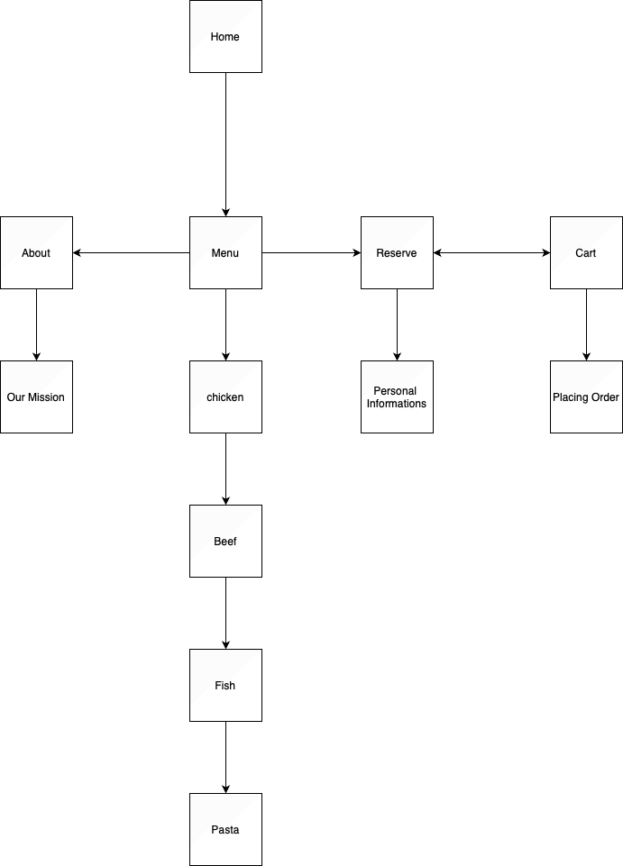

Page 5 of 5

* **Wireframe**:

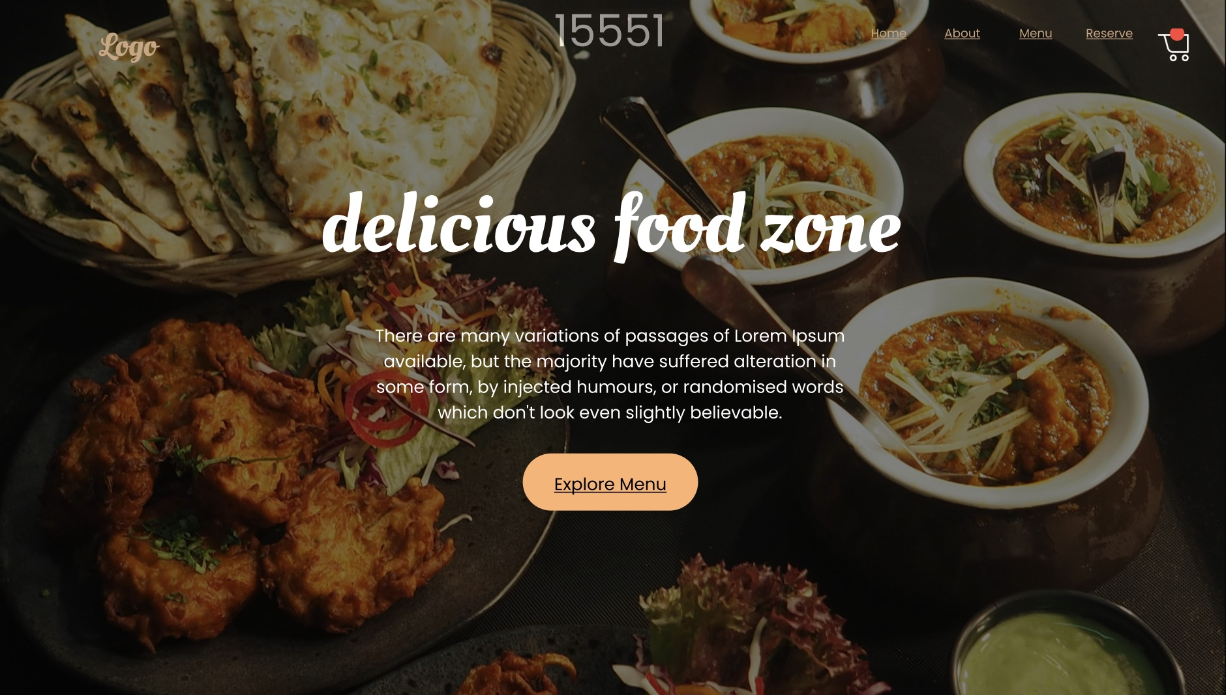

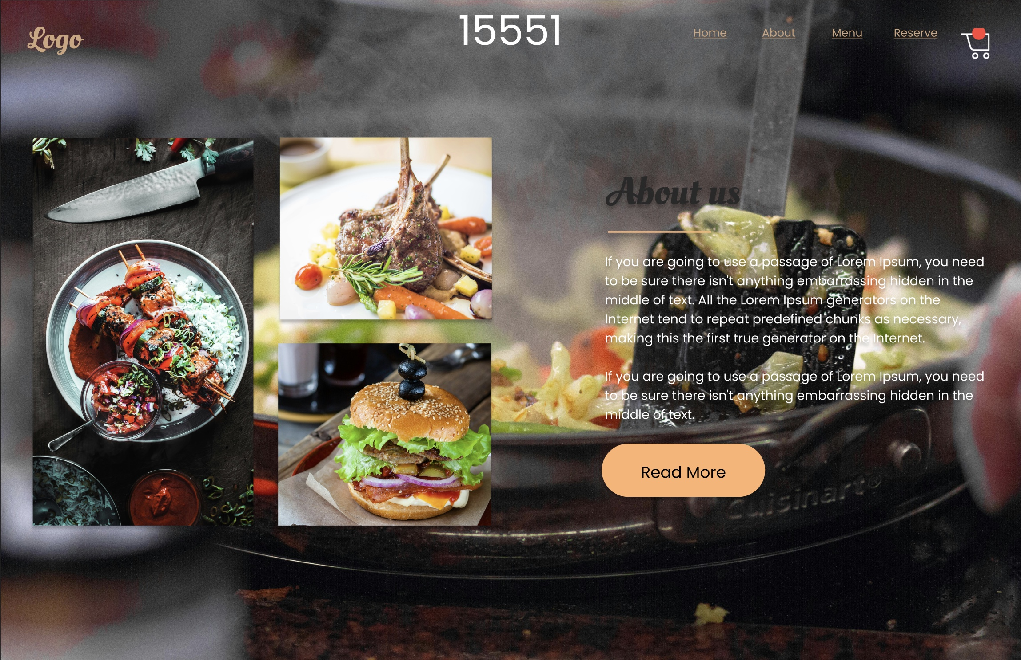

Page 6 of 7

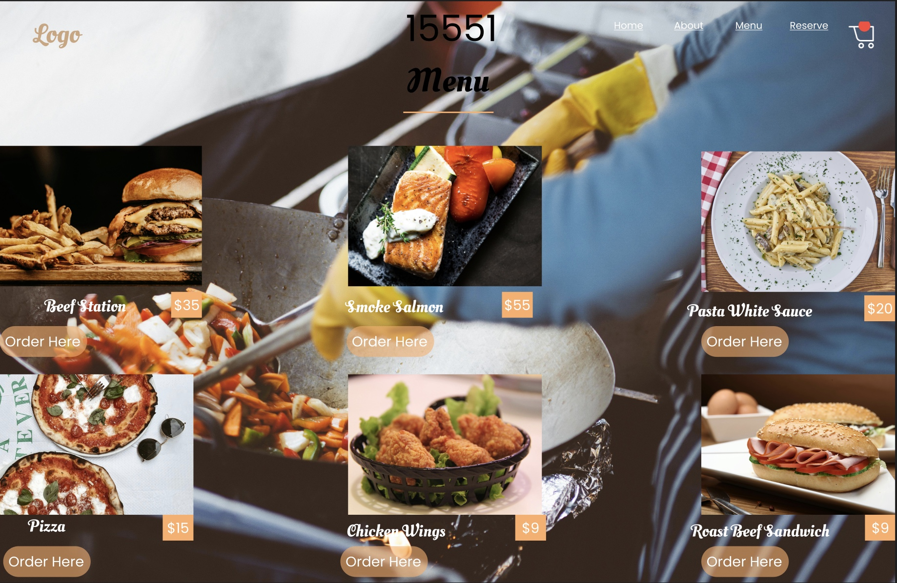

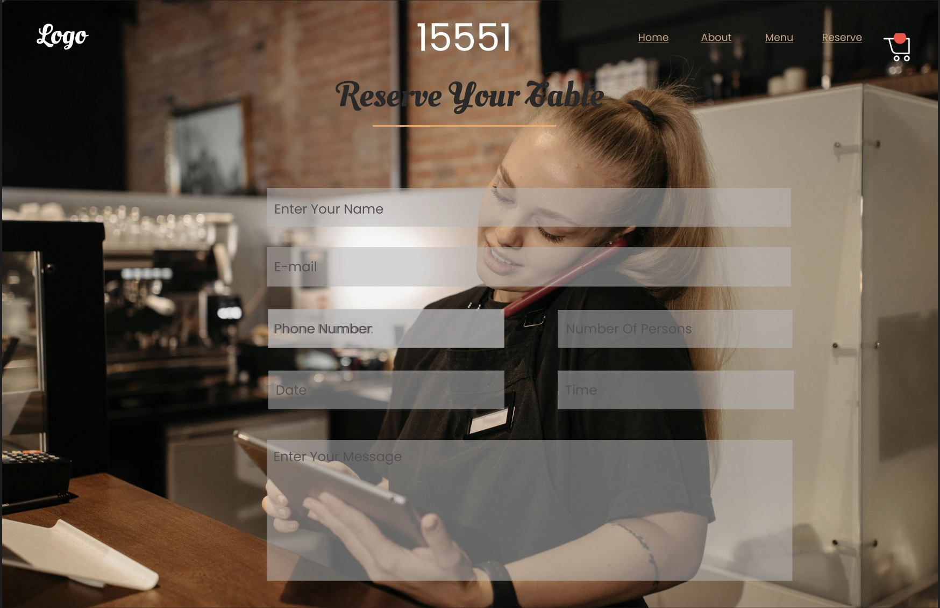

Page 7 of 7

<!DOCTYPE html>

<html lang="en">

<head>

<meta charset="UTF-8">

<meta name="viewport" content="width=device-width, initial-scale=1.0">

<title>Document</title>

</head>

<body>

<header></header>

<section></section>

</body>

</html>

https://www.figma.com/design/AF4rxr7fpICy6UtLzVqELH/Chiko-Restaurant?node-id=1-2&t=gwnas1qj0nmQK0gJ-1

Page 8 of 8